Cursor Movement by Hand Gestures

We all wonder it would have been so comfortable if we could control cursor through the use of hand gestures. Well our proposed project puts forward a hand gesture based system that allows user to control the pc mouse movements through the use of hand movements. Our system uses pc webcam in order to detect hand gesture movements. The system continuously scans the camera input for five finger hand like patterns. Once a hand is detected, the system then locks it as an objects. A flag is set on the object in order to mark it as an object. After the object has been flagged and detected, our system then constantly records its movements in terms of x y direction movement based coordinates. These coordinates are then mapped real time onto the mouse cursor to move it according to hand movements.
Our algorithm works as follows:
- Webcam video is captures using python video capture libraries.
- It is broken up into continuous image frames.
- Each frame is converted to grayscale.
- Each frame is now scanned to check fingertip design pattern.
- Once detected it is flagged as an object.
- System now tracks its movement within particular frame.
- This is tracked in terms of x,y coordinates.
- These x, coordinates are now mapped onto mouse cursor positioning.

Output Images:

In this system, the users can pick are red, blue, yellow colours. There are a few colour bands according to the backgrounds and the lighting conditions. This may vary in a different background. The user will have to pick colour such that, the colour wouldn’t match with the background or else, he has to choose the colour which will be highlighted in the current background.

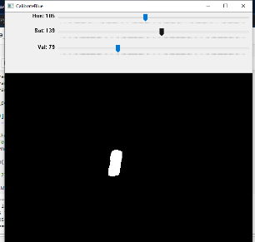
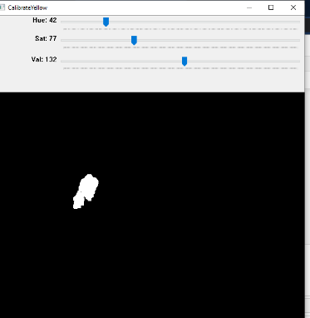
Fig 1: Detecting Yellow Colored Finger Fig 2: Detecting Blue Colored Finger
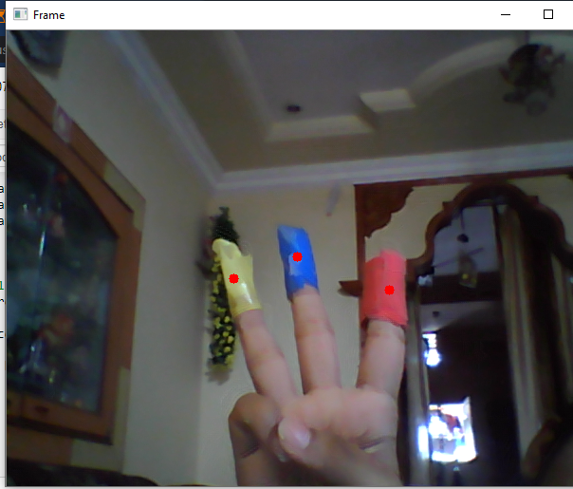
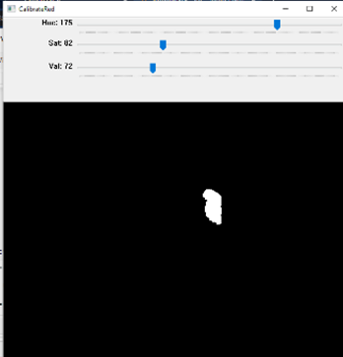

Fig 3: Detecting Red Colored Finger Fig 4: Finding Centroid of Colored fingertips

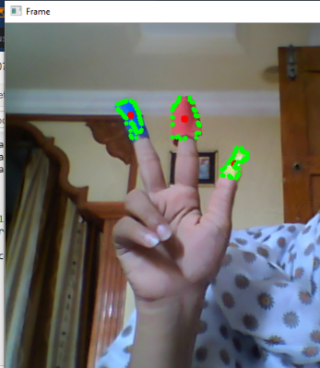
Fig 5: Contour and centroid of fingertips for mouse movements

- http://ieeexplore.ieee.org/xpl/articleDetails.jsp?tp=&arnumber=6173545&queryText%3DHand+Gesture

